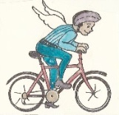
Travel Lite Challenge
3 Sample Announcements and Bulletins
Please tailor these to your own faith group

Gospel Justice is gearing up to begin the school year in the spirit of our creator. "For in Him all things were created, things in heaven and on earth." (Colossians 1:16). "The Cosmic Christ is not just saving ‘human beings’ but all of creation is included ---Earth, birds, and animals, too."--Richard Rohr, OFM.

What might each one of us do to save our planet? Let's kick off the year by biking to Mass. It's good for the pocket, too. Australia computes $21 is saved every time a person cycles 20 minutes to work. Gospel Justice is meeting with other interfaith Davis congregations to plan ways to reduce our carbon footprint. Gospel Justice meets the second Monday of the month in the Memorial Center at 7 pm. All are welcome.
Bulletin by Ann Privateer for Gospel Justice, St. James

Yolo Interfaith Alliance for Climate Justice: Travel Lite Challenge The Yolo Interfaith Alliance for Climate Justice is in the initial stages of planning a challenge to emphasize reducing our carbon footprint as we travel to church. On the first Sunday of each month, participating congregations will keep track of who comes to church by walking, biking, bus, or car pool, for a friendly competition for the most CO2 savings. We will culminate in a month-long celebration in May. Each church or place of worship will need a team to encourage biking and facilitate car-pooling, keep records, and encourage participation.

We will participate and are forming our coordinating committee. Members so far are Juliette (originator of the idea), Nick, and Neil. Other commission members who would like to join them, please contact one of the group or me.
Announcement by Juliette Beck at St. Martin’s Episcopal Church of Davis
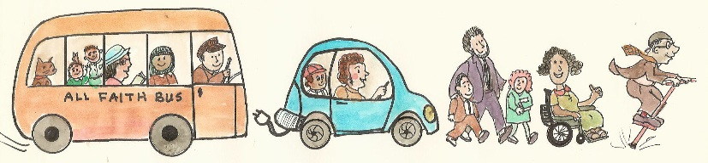
The Yolo Interfaith Alliance for Climate Justice has proposed a Travel Lite Challenge between faith groups. Members of each faith group are encouraged to bicycle, walk, bus, or carpool to the first worship of every month. Please sign in with a Green Sanctuary member in the social hall so we can show off to other faith groups just how green we are! We’ll need to know how your household arrived and your round trip mileage. Just look for the happy angel riding his bicycle. Your first chance is October 6! Bulletin by Lynne Nittler at the Unitarian Universalist Church of Davis

