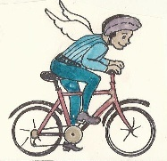
Travel-lite Challenge Pledge

Climate change affects all of God's creation. As people of faith, we have a special responsibility to do what we can to reduce our collective carbon footprint. Sign the pledge below to indicate your intention to “travel lite” to at least the first worship service each month.

Name  Phone  Email | Yes! I pledge to ride my bike the first worship of the month (or more!). | I'd like to carpool and/or can offer a ride to services. Here is my home address.

